Name: Lucas Pereira Silva

Computer Application

Assignment #4 - Databases

Introduction - Create a student database and create tables for student personal records and student academic record.

First of all, there were some issues to understand how the application works, however I did what was expected.

Methodology

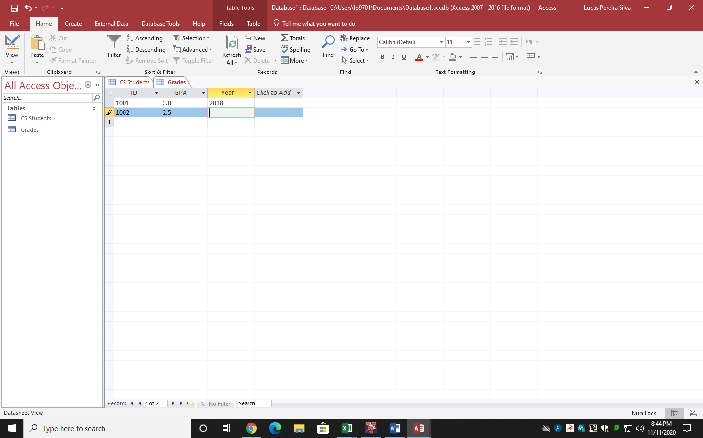

First of all, I was supposed to open the Microsoft Access, and choose the competences to be follow at the database.

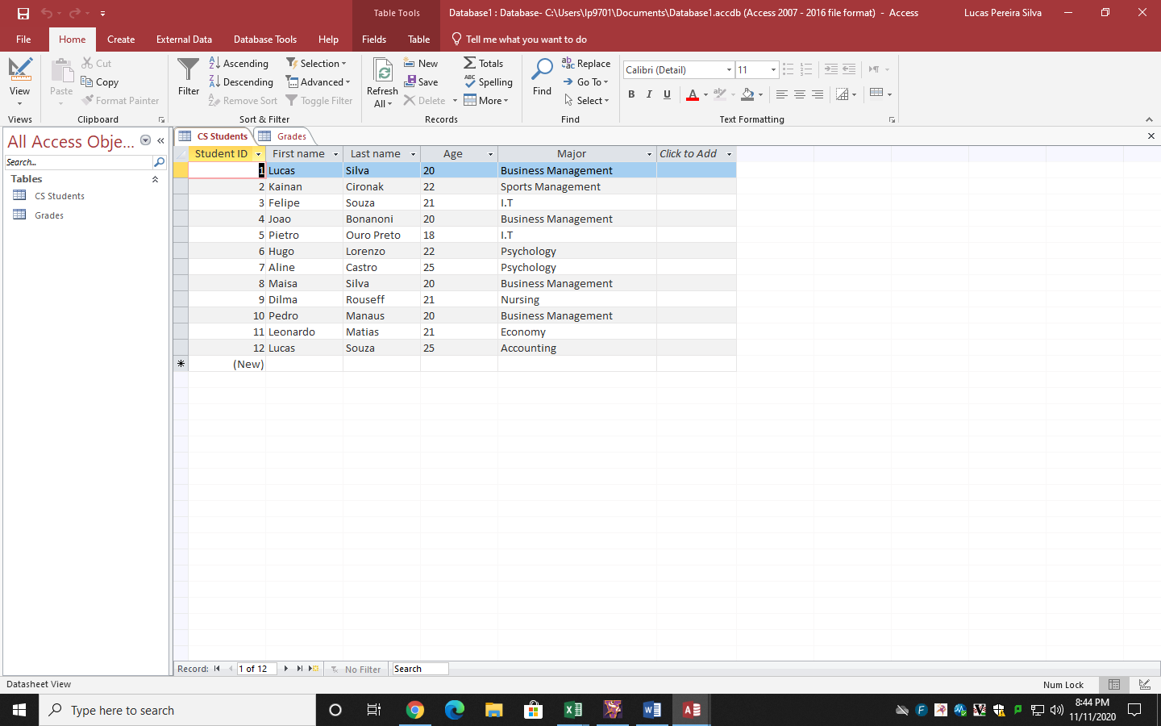

In second point, I created the databases based on names, age, major, year and G.P.A of the students.

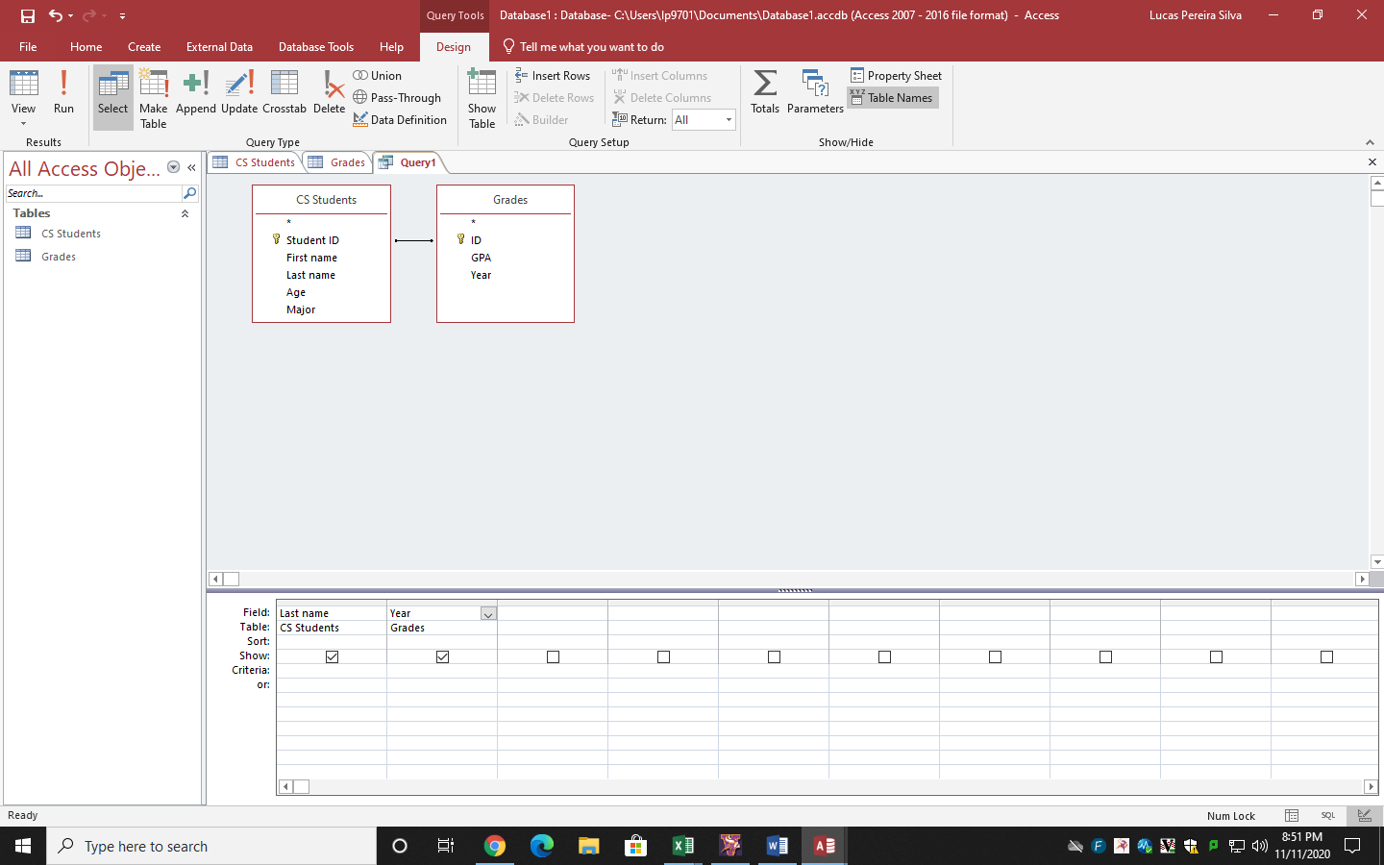

After that, I started to create the queries, that I was supposed to choose 5 different.

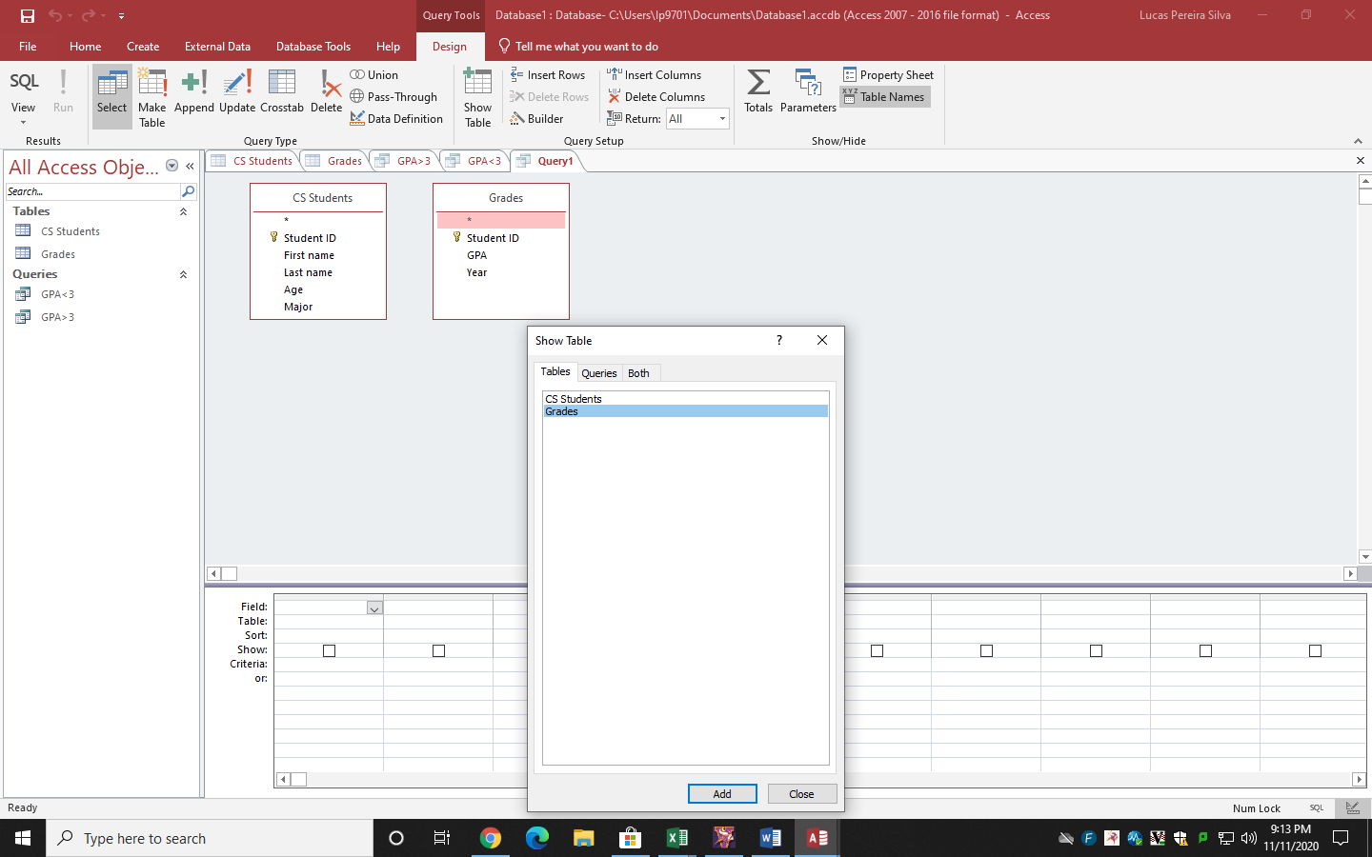

After create a query, I was supposed to connect my two tables to create a specific query and its competences.

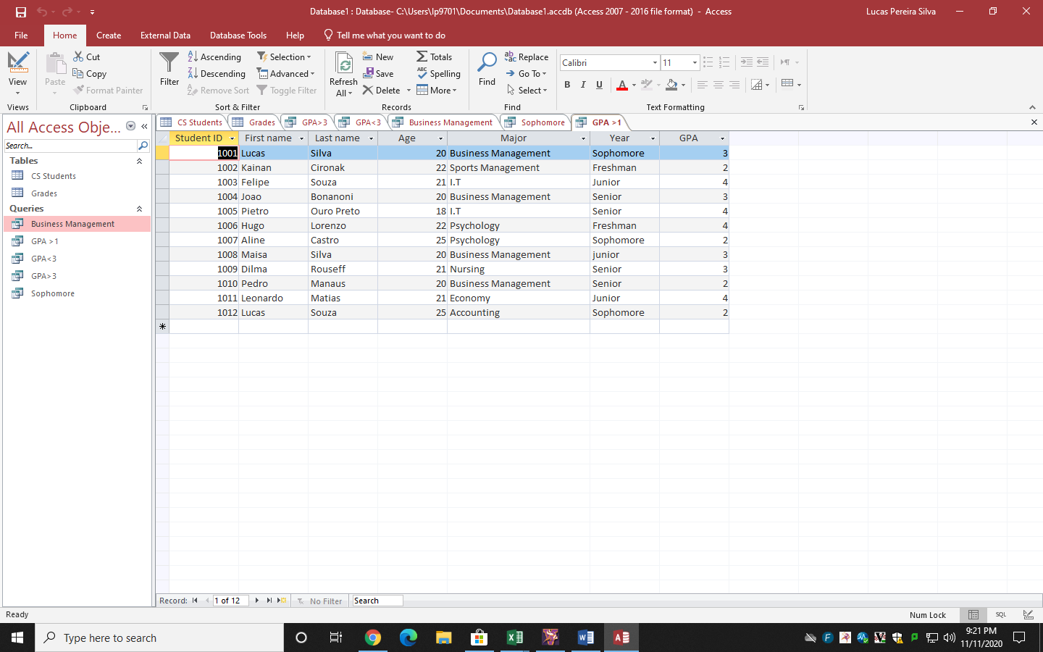

It is a result of one of the queries.

Results

After the Database got done, I realized that I improved my knowledge on Microsoft Access.

Conclusion

According to that was presented, the database got a good and decent layout, moreover it got organized, reaching everything that was expecting from me being a business student in relation of formulation and organization.